**PROJECT DESIGN PHASE-II**

**TECHNOLOGY ARCHITECTURE**

|  |  |
| --- | --- |
| Team ID | PNT2022TMID17579 |
| Project Name | Project – IOT Enabled Smart Farming Application |

**Architecture of smart farming application:**

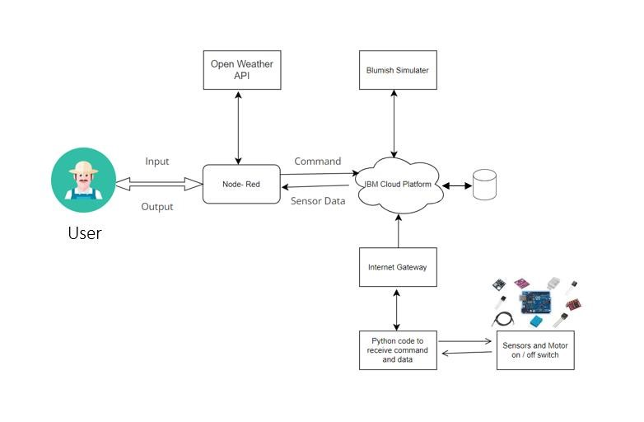

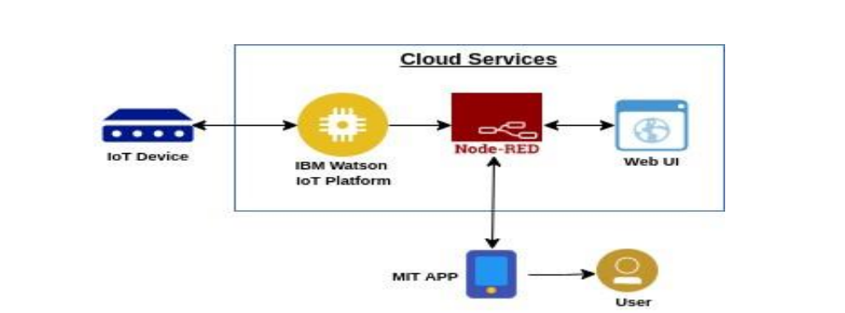

**TABLE-1 : COMPONENTS & TECHNOLOGIES:**

|  |  |  |  |
| --- | --- | --- | --- |
| **S.No** | **COMPONENTS** | **DESCRIPTION** | **TECHNOLOGY** |
| 1. | 1. User Interface | How user interacts with application e.g. Web | MIT App Inventor |
| 2. | 2. Application Logic-1 | Logic for a process in the application | Python |
| 3. | 3. Application Logic-2 | Logic for a process in the application | IBM Watson IOT service |
| 4. | 4. Application Logic-3 | Logic for a process in the application | IBM Watson Assistant |
| 5. | 5. Database | Data Type, Configurations etc. | MySQL, NoSQL, etc. |
| 6. | 6. Cloud Database | Database Service on Cloud | IBM Cloud |
| 7. | 7. File Storage | File storage requirements | IBM Block Storage or Other  Storage |
| 8. | 8. External API-1 | Purpose of External API  used in the application | Open Weather API |
| 9. | 9. Infrastructure  (Server / Cloud) | Application Deployment on  Local System / Cloud Local Server Configuration:  Cloud Server Configuration: | Local, Cloud Foundry. |

**TABLE-2: APPLICATION CHARACTERISTICS:**

|  |  |  |  |
| --- | --- | --- | --- |
| **S.No** | **CHARACTERISTICS** | **DESCRIPTION** | **TECHNOLOGY** |
| 1. | Open-Source  Frameworks | List the open-source frameworks used | Technology of Opensource framework |
| 2. | Security Implementations | Sensitive and private data must be protected from their production until the decision-making and storage stages. | Node-Red, Open weather App API,  MIT App Inventor |
| 3. | Scalable Architecture | scalability is a major concern for IoT platforms. It has been shown that different architectural choices of IoT platforms affect system scalability and that automatic real time decision-making is feasible in an environment composed of dozens of thousand. | Technology used |

**REFERENCES:**

<https://developer.ibm.com/patterns/online-order-processing-system-during-pandemic/>

<https://www.ibm.com/cloud/architecture/>